**How it works**

**Talk2bee is the conection between the Learner and Speaker.**

We belong to an economic model that uses peer-to-peer activity that allows individuals to acquire and provide goods and services to one another. Complementary, our platform will provide support material such as relevant business vocabulary and uptodate articles to promote reading.

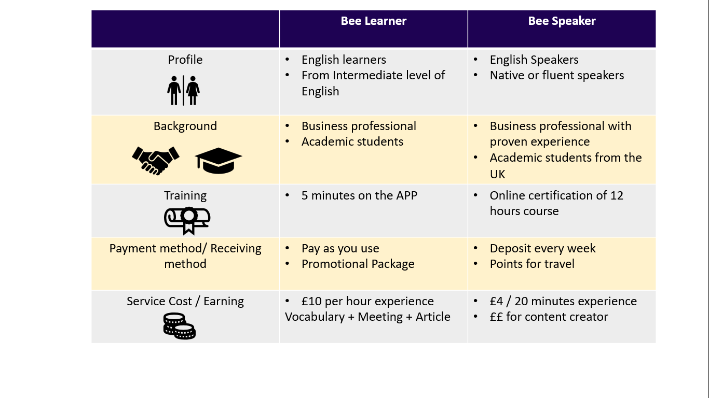

**Customer Service Model**

Talk2bee will provide all the techonologic software and support. As a Bee learner or Bee Speaker you just need to have a compatible device with internet, connect and enjoy the experience, that will be rich for both sides!

